Glassman Educational Therapy and Tutoring Calendar and Tuition

The 2026-2027 tutoring calendar is shown below as the year at a glance.
Each four-week session covers eight lessons during its corresponding (shaded) weeks.
Tuition is due by the first lesson of each session, as marked by the circled calendar dates. Tuition will increase in 2027 to $2,100 per four-week session.

Four-Week Sessions: Sun. – Thurs., occurring on green-shaded dates between:
1. Aug. 30* – Sept. 24, 2026
2. Sept. 27 – Oct. 29, 2026
3. Nov. 1 – Dec. 17, 2026
4. Jan. 10 – Feb. 4, 2027
5. Feb. 7 – March 11, 2027
6. March 14 – April 22, 2027
7. April 25 – May 20, 2027
8. May 23 – May 27, 2027 (abbreviated session)

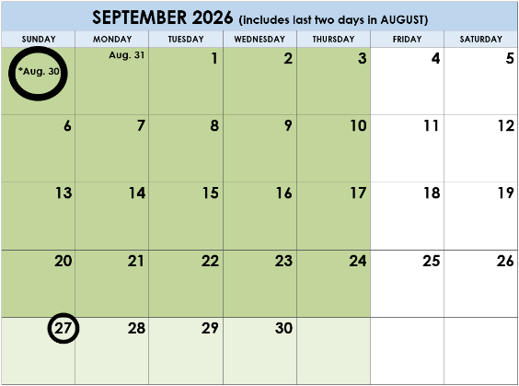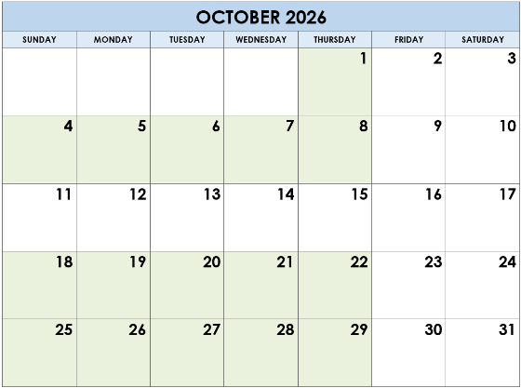
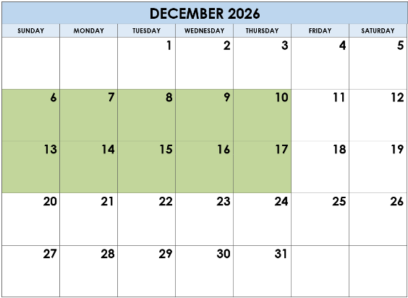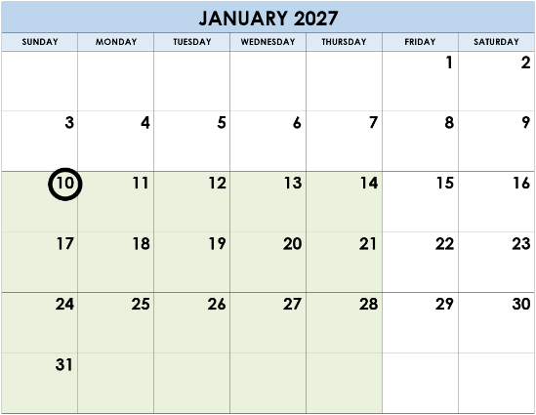
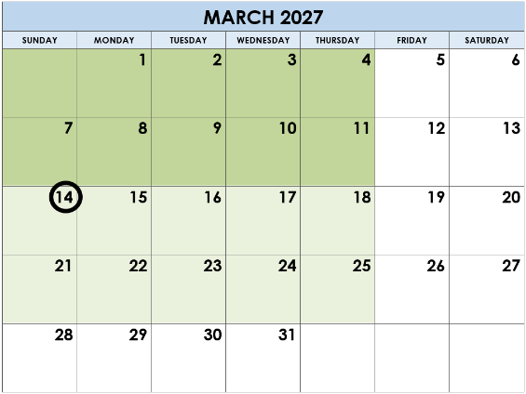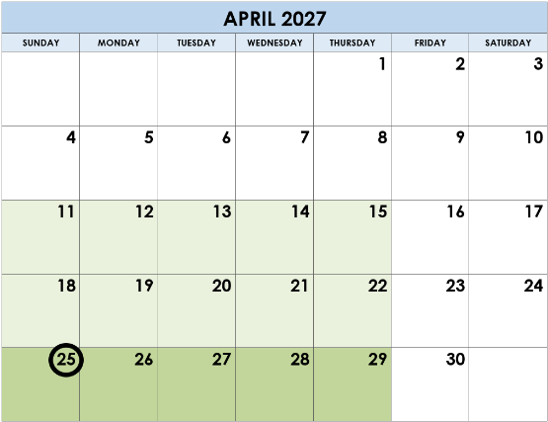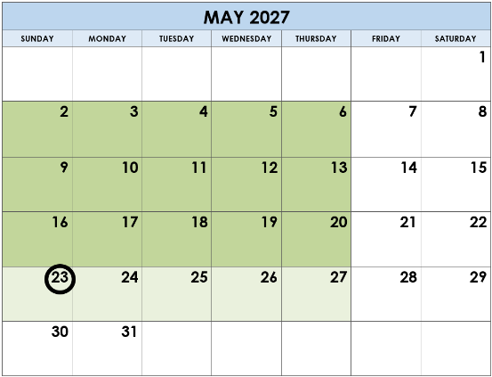

Copyright 2026, Glassman Tutoring www.GlassmanTutoring.com
“Blank Calendar” template © www.calendarlabs.com and customized for Glassman Tutoring

